Report for: | TRAFFIC & ROAD SAFETY ADVISORY PANEL
Date of Meeting: | 7th December 2021
Subject: | School Street Schemes
Key Decision: | Yes, recommendations will be referred to Cabinet for decision
Responsible Officer: | Dipti Patel – Corporate Director, Community
Portfolio Holder: | Varsha Parmar - Portfolio Holder for Environment
Exempt: | No
Decision subject to Call-in: | Yes, recommendations will be referred to Cabinet for decision
Wards affected: | Belmont, Hatch End, Marlborough, Rayners Lane
Enclosures: | Appendix A – Traffic monitoring data  Appendix B – Results of public engagement during trials  Appendix C – Public consultation documents  Appendix D – Schools questionnaire  Appendix E – Public consultation results  Appendix F – School questionnaire results

Section 1 – Summary and Recommendations

This report gives details about the six-month extension of the four school streets schemes trials in the London Streetspace Programme following the special TARSAP meeting on 22nd April 2021 and the results of a recent public consultation to consider the future of the schemes.

Recommendations:

The Panel is requested to recommend to Cabinet whether:

- the school street scheme by Grimsdyke School be removed or made permanent,

- the school street scheme by Marlborough School be removed or made permanent,

- the school street scheme by Newton Farm School be removed or made permanent,

- the school street scheme by Park High School be removed or made permanent

The Panel is requested to recommend to Cabinet that any school street schemes made permanent are subject to a review of the traffic signing and any necessary improvements made.

Reason: (For recommendations)

The maximum 18-month experimental period allowed for the school streets traffic management orders under current legislation ends on 27th March 2022 and a decision is required on whether to remove the schemes or make them permanent.

Section 2 – Report

Introduction

- The Covid-19 health emergency has significantly affected the way we use public transport, and the ways in which we travel. The social distancing restrictions introduced by the Government since March last year to control the spread of the virus and rate of infection also had a severe impact on the use of public transport and on the way we travel.

- The government issued statutory guidance under Section 18 of the Traffic Management Act 2004 to all highway authorities in England requiring local authorities in areas with high levels of public transport use to take measures to reallocate road space to people walking and cycling to encourage active travel and enable social distancing. In response to this the GLA / TfL developed the London Streetspace Programme (LSP) and invited London Boroughs to promote suitable streetspace schemes in accordance with TfL’s guidance. Harrow participated in the programme and subsequently made funding applications and secured funding for four school streets.

- The purpose of the programme was to encourage the public to walk or cycle to school where previously they may have used the car and these improvements aimed to support those that are able to walk where distances are less than 2 km (a 10 minute walk) or cycle if the journey less than 5 km. Active travel avoids use of the car for short journeys, is often cheaper and quicker for the public, and helps improve air quality and public health.

- TfL’s “Healthy streets for London” guidance is a key part of the Mayor’s Transport Strategy and highlights the following facts about travel and transport in the capital highlighting the potential for switchable trips.

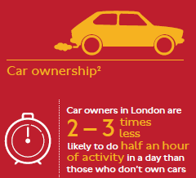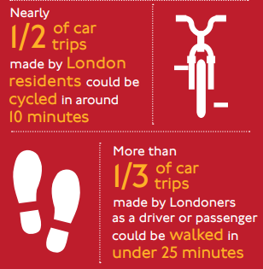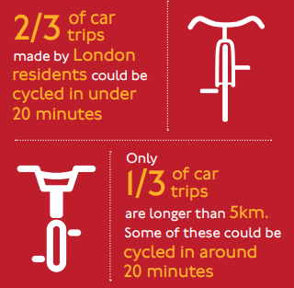

- The schemes can also allow the Council to make longer lasting changes in travel to improve the environment by tackling the causes of climate change and adapting our networks to changing travel patterns and to further increase the level of walking and cycling in accordance with the Council’s Transport Local Implementation Plan.

Options considered

- The four school streets trials have been implemented using an experimental traffic management order which allows schemes to be reviewed for a maximum period of up to 18 months before a firm decision needs to be made about their future. The schemes have been operating for approximately 15 months to date.

- The 18 month period ends in March 2022 and so this report sets out the two options available for each scheme:

- Remove the scheme
- Make the scheme permanent

School streets schemes

- Detailed guidance for the London Streetspace Programme was released to the London boroughs by TfL in mid May and can be found at http://content.tfl.gov.uk/lsp-interim-borough-guidance-main-doc.pdf

- Proposals were submitted against the school streets programme and an allocation of £135,000.00 was allocated to Harrow to deliver four school streets schemes in 2020/21.

- The proposals for school streets measures were developed taking account of the severity of congestion and access problems at schools, impact on road safety, active travel and air pollution and also the receptiveness of the schools to work with the Council to implement and operate these types of schemes.

- Three primary schools and one secondary school were implemented as shown in the list below.

Ref | Scheme | Budget
SS-01 | Grimsdyke Primary School, Hatch End | £30,000
SS-02 | Newton Farm Primary School, Rayners Lane | £30,000
SS-03 | Marlborough Primary School, Wealdstone | £30,000
SS-04 | Park High School, Stanmore, Middx. | £45,000
 | Total | £135,000

- School streets operate on the principle that the streets surrounding a school are restricted to vehicular traffic at opening and closing times except for local residents living in the street. They improve air quality, reduce congestion and improve safety and encourage more active travel. The restrictions are enforced by using either fixed or mobile CCTV cameras with automatic number plate recognition systems.

- The school streets were introduced in October 2020 and initially subject to a six-month trial which was monitored by undertaking traffic surveys and through reviewing feedback from a wide variety of stakeholders including residents, schools, parents, ward councillors and the emergency services. The first six months of operation of the experimental traffic management is also a statutory consultation period and details of representations received were also collated during the review.

- TARSAP received a report in April 2021 and decided that the school streets scheme trials should be extended for another 6 months to allow the schemes to be evaluated further.

Review of six-month trial extension (Apr – Oct 2021)

- The review is an important part of helping us understand the impact of the schemes and monitoring of traffic and stakeholder opinions has been undertaken.

- Traffic surveys have been undertaken periodically to monitor any changes in walking, cycling and vehicle activity during the school street trials. A detailed summary of the surveys can be seen in Appendix A. To summarise the key findings are:

- There has been an increase in walking at the schools, particularly the three primary schools.

- There has been a reduction in vehicle traffic at the schools.

- Cycling activity has not changed significantly except at Grimsdyke School during the most recent survey in July 2021.

- Feedback from a wide variety of stakeholders including residents, schools, parents and students is an important part of helping us understand the impact of the schemes. An engagement portal on the commonplace web platform was used to receive details of their experiences of the schemes during the trial period.

- The detailed feedback received from the school streets trials extension between April and October 2021 can be seen in Appendix B. To summarise the findings are as follows:

- The number of responses was low with 152 received over the 6 month extension.

- The majority of respondents to the survey lived outside of the school street scheme areas (question 1).

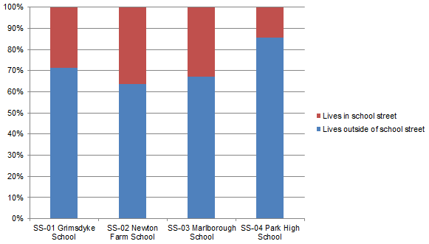

- The general sentiments shown about the schemes during the trial from the wider community were more negative than positive (question 6).

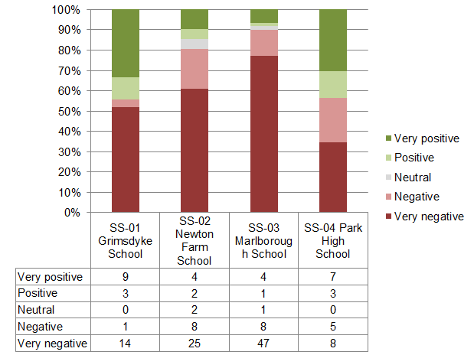

- The reasons for these sentiments (question 7) are shown in the table below and the top four reasons are highlighted.

 | SS-01 Grimsdyke School | SS-02 Newton Farm School | SS-03 Marlborough School | SS-04 Park High School
Traffic / parking on surrounding roads | 12  (15.4%) | 17  (15.9%) | 33  (19.4%) | 15  (25.4%)
Road safety / speeding vehicles | 12  (15.4%) | 15  (14.0%) | 11  (6.5%) | 10  (16.9%)
CCTV and enforcement | 9  (11.5%) | 12  (11.2%) | 21  (12.4%) | 6  (10.2%)
Air quality / public health | 13  (16.7%) | 10  (9.3%) | 16  (9.4%) | 9  (15.3%)
Access for deliveries / visitors | 6  (7.7%) | 14  (13.1%) | 26  (15.3%) | 5  (8.5%)
Inconvenience | 6  (7.7%) | 20  (18.7%) | 33  (19.4%) | 4  (6.8%)
Safety of cyclists | 7  (9.0%) | 8  (7.5%) | 4  (2.4%) | 3  (5.1%)
Pedestrian crossing points | 5  (6.4%) | 3  (2.8%) | 6  (3.5%) | 3  (5.1%)
Other | 5  (6.4%) | 5  (4.7%) | 11  (6.5%) | 3  (5.1%)
Access for disabled drivers | 3  (3.8%) | 3  (2.8%) | 9  (5.3%) | 1  (1.7%)

- The main concerns by respondents are shown as Traffic / parking on surrounding roads, Road safety / speeding vehicles, CCTV and enforcement, Air quality / public health, Access for deliveries / visitors and Inconvenience.

- On 19th October the Council received a petition from residents living close to the Marlborough school area opposed to the school street scheme. The petition states:

We the residents of Marlborough ward, the undersigned, are opposed to School streets scheme and double yellow lines in the adjacent roads near Marlborough Primary School. We call on Harrow Council to:

1. To get rid of the School Streets Scheme and double yellow lines from the relevant roads
2. to fully consult with local residents on any future proposals regarding these two aspects.

- The petition is signed by 45 residents living in Ranmoor Gardens, Ranmoor Close, Leys Close, Marlborough Hill, Rugby Close and Badminton Close.

- The petitioner’s reasons for requesting the removal of the school street scheme are not provided but the engagement survey during the trial does highlight that the most reasons are to do with inconvenience, traffic / parking on surrounding roads and access for visitors.

- The yellow lines are not part of the school street scheme but are part of the wider controlled parking zone that includes Marlborough Hill. This specific issue will therefore be reported to the March 2022 TARSAP meeting separately when an officer report will be provided for members to review.

- The view of the school community is more supportive of the schemes and the Head Teachers of the schools were asked to provide feedback which is summarised as follows:

- Grimsdyke School – the introduction of the scheme was initially positive providing a clearer pathway for the students to enter and leave the school, however, problems with parents continuing to drive to school and parking and has been displaced to other locations in the vicinity so the issues need to be reviewed.

- Marlborough School – the school is fully supportive of the scheme and there are visibly more children walking to school, the enforcement needs to be improved and there are some issues for deliveries and visitors to the school that need to be reviewed, the scheme improves safety for children and the community generally.

- Newton Farm School – the scheme has increased the number of children who walk, cycle or park and stride to school and there is a reduction in car use, educationally this has been a success to improve dialogue with parents and children regarding the school travel plan, additional enforcement should be provided to improve the scheme, we are supportive of continuing the scheme.

- Park High School – it is essential that the scheme is maintained to keep safer roads for students and residents, there are less conflicts and abusive encounters between residents and parents caused by parking, there are no complaints from the parents, this has been a positive health and safety improvement for the students and fosters improved relationships with neighbouring residents, the scheme should be made permanent.

- The review of the traffic data indicates that there are positive impacts on walking and reduced vehicle use demonstrating that the schemes are achieving the aims and objectives. However, in terms of stakeholder opinions the local community remains negative about the schemes whilst the school community is mainly positive.

Public consultation (Nov / Dec 2021)

- At the end of the trial extension a public consultation to determine the future of the schemes was undertaken which ran from Monday 18th October to Sunday 7th November. The consultation was aimed at:

- Residents in the School Streets
- Residents in the surrounding areas of each School Street
- Headteachers and school community

- The Commonplace engagement portal used during the trial extension was closed and information was sent to all residents, businesses, schools and school communities to advise them of the public consultation and give details of how they can participate online or request a hardcopy of the consultation via Access Harrow. The consultations were intended to seek participants views on the future of the schemes. Details of the consultation leaflets distributed, and the questionnaire used online can be seen in Appendix C. The consultation was available online at www.harrow.gov.uk/schoolstreetsconsultation

- A separate consultation within the school communities was also organised. Headteachers were contacted directly and staff in the Travel Planning team worked with them to engage with their school communities through the relevant channels. The ‘voice of the child’ is considered a critical part of this engagement and we worked closely with the schools to capture this. A questionnaire was developed for this purpose which can be seen in Appendix D.

- All responses received during both consultation exercises have been analysed and the results of the public consultation can be seen in Appendix E and the results of the consultation with the school community can be seen in Appendix F.

- The findings of the public consultation are summarised as follows:

- The number of responses was relatively low with 249 received. This represents only a 4% response rate from the local community.

School | Leaflets distributed | Responses received | Percentage response
SS-01 Grimsdyke School | 573 | 26 | 5%
SS-02cNewton Farm School | 1618 | 54 | 3%
SS-03 Marlborough School | 1971 | 52 | 3%
SS-04 Park High School | 1749 | 117 | 7%
Total | 5911 | 249 | 4%

- Most respondents lived outside of the school street area as shown in the graph below (Question 2). Park High school also received responses from students directly.

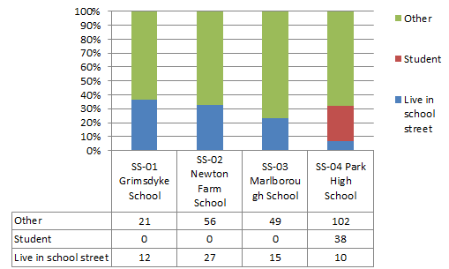

- The proximity of respondent to the school is shown in the graph below (Question 3). Over 75 % of respondents live less than 1 mile from the primary schools whilst for Park High School it is approximately 50% with 50% travelling further than 1 mile.

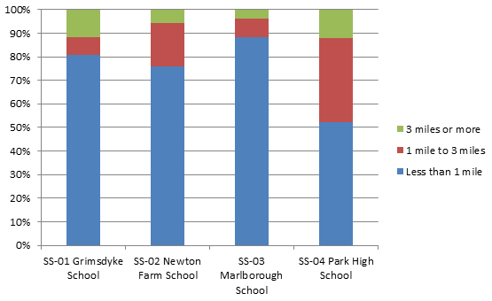
- The change in mode of transport (questions 4 and 5) before and after the school street schemes were introduced is shown in the table below. This shows that respondents indicated an increase in walking / cycling journeys and a reduction in car journeys to the school (highlighted) and demonstrates the positive impact on modal shift.

 | SS-01 Grimsdyke School |  | SS-02 Newton Farm School |  | SS-03 Marlborough School |  | SS-04 Park High School
 | Before | After | Before | After | Before | After | Before | After
Walking | 3 | 3 | 23 | 26 | 13 | 15 | 58 | 65
Cycling | 2 | 3 | 3 | 3 | 3 | 6 | 0 | 2
Car / motorbike | 16 | 15 | 21 | 17 | 26 | 22 | 28 | 24
Public transport | 0 | 0 | 0 | 1 | 3 | 3 | 19 | 18
Not applicable | 5 | 5 | 7 | 7 | 7 | 6 | 12 | 8

- The aims of the school street schemes were considered important to a high proportion of respondents (question 9) as shown in the table below. This highlights agreement with the purpose and ambition of the school street schemes.

 | SS-01 Grimsdyke School |  | SS-02 Newton Farm School |  | SS-03 Marlborough School |  | SS-04 Park High School
(I) Important (NI) Not very important | I | NI | I | NI | I | NI | I | NI
Improving general health and wellbeing | 24 | 2 | 45 | 9 | 40 | 12 | 107 | 10
Encouraging more families and individuals to walk and cycle to school or in the local area | 21 | 5 | 39 | 15 | 39 | 13 | 103 | 14
Making it safer to cross the road on foot | 21 | 5 | 48 | 6 | 40 | 12 | 115 | 2
Making it safer to walk in the local area | 21 | 5 | 47 | 7 | 41 | 11 | 111 | 6
Improving air quality | 20 | 6 | 45 | 9 | 47 | 5 | 110 | 7
Providing a more pleasant and calm atmosphere at school drop-off and pick-up | 19 | 7 | 44 | 10 | 32 | 20 | 104 | 13
Making it safer to cycle in the local area | 17 | 9 | 41 | 13 | 32 | 20 | 101 | 16

- The respondents indicated a higher level of support overall for retaining the schemes (question 10) than the previous engagement during the trials as shown in the graph below. Grimsdyke school and Park High school showed support, Newton Farm school showed marginal opposition and Marlborough school showed a higher level of opposition.

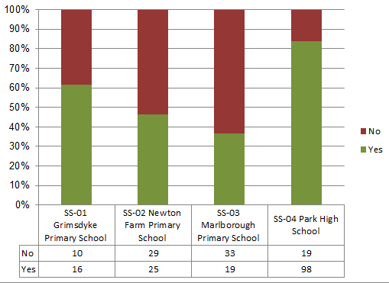

- The main reasons for the responses to the question about retaining the schemes are shown in the table below (question 11). All of the schools show road safety as important. However, where respondents showed more support for the schemes the safety of pupils, active travel and air quality was important but where there was more opposition to the schemes access for deliveries / visitors and the impact of displaced traffic was more important.

 | SS-01 Grimsdyke School | SS-02 Newton Farm School | SS-03 Marlborough School | SS-04 Park High School
Road safety / speeding vehicles | 15 | 26 | 22 | 78
Safety of pupils | 13 | 27 | 10 | 72
Impact of displaced traffic / parking congestion on surrounding roads | 12 | 35 | 32 | 44
Air quality / public health | 10 | 14 | 22 | 52
Active travel – cycling, walking, scooting | 8 | 18 | 18 | 54
CCTV and enforcement | 7 | 14 | 4 | 34
Access for deliveries / visitors | 7 | 20 | 25 | 4
Access for disabled drivers | 2 | 4 | 14 | 12
Pedestrian crossing points | 2 | 6 | 7 | 26

- It should also be noted that the two schemes with permanent CCTV camera enforcement at Park High School and Grimsdyke School have demonstrated public support whilst the schemes that rely on more infrequent mobile CCTV camera enforcement at Newton Farm School and Marlborough School have less support. The comments and feedback consistently indicate that better enforcement is needed at these particular sites due to a higher level of non-compliance with the restrictions observed by residents and this may be a factor in the results. If members were considering retaining these particular schemes, then installing permanent CCTV cameras would be an important consideration to address those concerns.

- The findings of the school pupil consultation are summarised as follows:

- It can be seen that there were no responses to the school pupil questionnaire for Park High School and this is because students responded to the main public consultation instead as shown previously. However, all the views of students have been collated across both consultations. The response rate at the three primary schools was very high with 823 responses received.

- The questions concerning current and future travel preferences (questions 4 and 5) showed the high proportion of walking and park & stride currently and an interest in more scooting and cycling to school in the future.

- Respondents were asked if they had noticed any changes since the schemes were introduced (questions 6, 7, 8 & 9). The table below shows all the responses were positive towards the impact of the schemes.

 | SS-01 Grimsdyke Primary School |  | SS-02 Newton Farm Primary School |  | SS-03 Marlborough Primary School
Question | No | Yes | No | Yes | No | Yes
I see more of my friends walking, cycling or scooting to school | 120 | 228 | 49 | 258 | 51 | 117
I feel safer on my journey to school | 26 | 322 | 14 | 293 | 29 | 139
It is easier to cross the road outside my school | 66 | 282 | 73 | 234 | 53 | 115
I can smell car fumes outside my school | 251 | 97 | 230 | 77 | 125 | 43
The street outside my school feels calmer | 98 | 250 | 65 | 242 | 61 | 107

- The respondents indicated a high level of support overall for retaining the schemes at all schools. This shows that the schemes have had a very beneficial impact on the school community (question 11).

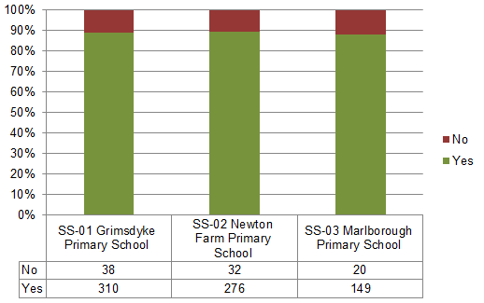

- The consultations indicate very strong support from the school community for all the schemes.

Summary of the consultation and conclusions

- There has been a lot of public engagement and consultation on the school street schemes since April and there is a lot of information for members to consider. Taking account of all the feedback received the main findings are as follows:

- The largest number of respondents were from the school community (823 no.) who were overwhelmingly positive about the schemes and would like them retained.

- All the Head Teachers have showed support for the schemes and highlighted benefits and some issues for consideration, but generally they would like the schemes retained.

- The number of responses from the local community has been comparatively low (249 no.) and has been only a third of that from the school community. There is support shown for the Park High school and Grimsdyke school schemes to be retained but more opposition to retaining Marlborough school and Newton Farm School.

- The traffic data and opinion surveys show that the schemes have delivered more walking and cycling and less car use and this modal shift will help to improve public health, road safety and more sustainable transport in accordance with the Council’s transport aims.

- There is therefore a strong case for retaining the four schemes on this basis.

- The recommendations seek members views on whether to retain or remove each individual scheme based on the evidence provided.

- Should members decide to retain schemes then it is recommended that the traffic signing arrangements be reviewed and improved to ensure that motorists are aware of the restrictions.

Staffing/workforce

- The monitoring and enforcement of the schemes will be undertaken by existing staff resources within the Traffic, Highways & Asset Management team and Parking & Network Management team.

Ward Councillors’ comments

- Ward councillors’ comments have not been sought for this report because all members are receiving a regular update on progress with the programme through a regular programme of reviews during the scheme trials.

Performance Issues

- The implementation of schemes in the programme will be monitored including the traffic levels of different travel modes, the operational performance of the road network and public opinion.

Environmental Implications

- There are environmental and health benefits from delivering the school street schemes. The main benefits are in improving air quality, road safety and public health.

- The benefits identified were achieved by reducing car travel, reducing congestion, reducing casualties, encouraging active travel and from reduced vehicle emissions.

Data Protection Implications

- There are no data protection implications

Risk Management Implications

- A design risk assessment has been undertaken during scheme development under the Construction (Design & Management) Regulations in order to manage any potential health and safety risks.

- The delivery of each scheme in the programme has been subject to separate risk assessments.

Procurement Implications

- Where needed, consultants and contractors have been procured to investigate, develop and deliver some proposals. This is business as usual. The work has been procured in line with the Public Contracts Regulations 2015 and the Council’s Contract Procedure Rules.

Legal implications

- The Traffic Management Act 2004 places an obligation on authorities to ensure the expeditious movement of traffic on their road network. Authorities are required to make arrangements as they consider appropriate for planning and carrying out the action to be taken in performing the duty.

- The Statutory guidance “Traffic Management Act 2004: network management in response to COVID-19” is an additional statutory guidance issued by the Secretary of State for Transport. It sets out high-level principles to help local authorities to manage their roads and what actions they should take. Local authorities in areas with high levels of public transport are required to take measures to reallocate road space to people walking and cycling, both to encourage active travel and to enable social distancing.

- The traffic and parking restrictions in the schemes have been given effect by the making of experimental traffic management orders in accordance with section 9 and 10 of the Road Traffic Regulations Act 1984. The orders came into operation on 28th September 2020. The first 6 months of operation is a period in which to consider any representations made about the introduction of the scheme. All the representations and comments made during this statutory consultation period were considered at the special meeting of TARSAP on 22nd April.

- The maximum length of time that an experimental traffic management order can operate is 18 months and the current orders are due to expire on 27th March 2022. It is therefore necessary before the expiry of the experimental orders to determine if the schemes should be removed, and the orders revoked, or the schemes made permanent and the orders confirmed as permanent orders.

Financial Implications

- TfL awarded funding of £135,000 in 2020/21 to introduce the four school street schemes. The cost of monitoring and enforcement during the extension period has been met from existing budgets within the relevant service areas.

- If members decide to make the schemes permanent, they can continue to be maintained in the future under the current operational arrangements from existing budgets within the relevant service areas.

- If permanent CCTV equipment is required for Newton Farm School and Marlborough School, instead of relying on mobile CCTV enforcement, then the cost of installing this would be approximately £80k. There would be some on-going revenue costs associated with these cameras as well. Both costs would need to be met from within the budget of the Parking Service.

- If members decide to remove the schemes completely then the cost of removal would be approximately £20k. This cost would need to be met from Highway revenue budget. Camera equipment would be reused for other purposes.

Equalities Implications / Public Sector Equality Duty

- The measures proposed in the programme accord with the Council’s Transport Local Implementation Plan 3 (LIP). The LIP underwent an Equalities Impact Assessment and had due regard to the need to eliminate discrimination, advance equality of opportunity and foster good relations between persons who share a relevant protected characteristic and those who do not share it as required under section 149 of the Equality Act 2010.

- TfL have highlighted the need to assess the impacts of schemes on all protected characteristics and the schemes have been subject to a separate EqIA. The schemes do have positive benefits for the groups in the table below:

Protected characteristic | Benefit
Sex | Parents with young children will generally benefit most from schemes that prioritise walking and cycling because improved road layouts and public realm provide improved safety, security and convenience. Mothers are more likely to have full time care of young children and are therefore more likely to be positively impacted by these proposals.
Disability | People with physical and visual impairment generally benefit most from schemes that prioritise walking because improved road layouts and public realm provide ease of access with fewer obstructions, improved safety, security and convenience to access the town centre and facilities.  The wider benefits of active travel and more healthy lifestyles can reduce or prevent the affects of health conditions that affect mobility such as diabetes or heart disease and these proposals could in the long term reduce people developing disabilities.
Age | Young children and elderly people generally benefit most from schemes that prioritise walking and cycling because improved road layouts and public realm provide improved safety, security and convenience and improved access to the town centre and facilities. A reduction in the influx of traffic into an area will reduce particulate emissions and air pollution, to which children are particularly sensitive.  Older children may benefit from enhanced cycling schemes as they provide a safer means of cycling to school and other activities.  The schemes form part of wider school travel planning objectives , which should see longer term health impacts for children and young people.

Council Priorities

- The proposed programme detailed in the report supports the Harrow Ambition Plan and will contribute to achieving the administration’s priorities:

Corporate priority | Impact
Building homes and infrastructure  Improving the environment and addressing climate change | Measures to control the level of traffic will reduce pollution from vehicle emissions and encourage a greater uptake of walking and cycling with wider public health benefits.  Measures to control the level of traffic will also benefit more vulnerable residents in residential estates by reducing air pollution and improving road safety and accessibility.
Addressing health and social care inequality  Tackling poverty and inequality  Thriving economy | An improvement in public health will reduce pressure on health services particularly during the current health crisis.  Measures to support social distancing will help to reduce fear of the risk of infection and encourage more people to make local journeys by walking and cycling .  More walking journeys can encourage people to shop locally and thereby support the local economy.

Section 3 - Statutory Officer Clearance

Statutory Officer: Jessie Man
Signed on behalf of the Chief Financial Officer

Date: 24/11/2021

Statutory Officer: Jimmy Walsh
Signed on behalf of the Monitoring Officer

Date: 25/11/2021

Section 3 - Procurement Officer Clearance

Statutory Officer: Nimesh Mehta
Signed by the Head of Procurement

Date: 22/11/2021

Section 3 – Corporate Director Clearance

Statutory Officer: Dipti Patel
Signed by the Corporate Director - Community

Date: 29/11/2021

Mandatory Checks
Ward Councillors notified: YES

EqIA carried out: YES

EqIA cleared by: Dave Corby, Community - Equality Task Group (DETG) Chair

Section 4 - Contact Details and Background Papers

Contact:

David Eaglesham – Head of Traffic, Highways & Asset Management
E- mail David.Eaglesham@harrow.gov.uk

Background Papers:

TfL Streetspace for London guidance - http://content.tfl.gov.uk/lsp-interim-borough-guidance-main-doc.pdf

TfL Healthy Streets for London - http://content.tfl.gov.uk/healthy-streets-for-london.pdf

Transport Local Implementation Plan 3 – https://www.harrow.gov.uk/downloads/file/26428/harrow-transport-local-implementation-plan

Walking, Cycling & Sustainable Transport Strategy - https://www.harrow.gov.uk/downloads/file/26432/harrow-walking-cycling-and-sustainable-transport-strategy

Call-In Waived by the Chair of Overview and Scrutiny Committee  (for completion by Democratic Services staff only) |  | YES/ NO / NOT APPLICABLE*  * Delete as appropriate  If No, set out why the decision is urgent with reference to 4b - Rule 47 of the Constitution.

